STAT 351 Homework 7 Due by 11.59 pm on Thursday, May 27
First Name : Last Name :
Instructions:
- Please see the lecture notes on May 18 and 20 for similar problems.
- Please write all the important steps of your work to get full points. If there are no clear steps of your work, you may lose points.
- Please provide only one final answer and if a question has a number for the final answer, then please circle or box the final answer.
- You are encouraged to work on this assignment in groups. However, you cannot write exactly same explanations.
- If I see the exact same explanation on two or more assignments, then I’ll give zero points for those assignments.

Problem 1: An electronic system has each of two different types of components in joint operation. Let X and Y denote the lengths of life, in hundreds of hours, for components of type I and type II, respectively.
The joint pdf is given by
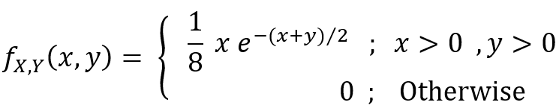

(a) Explain whether X and Y are independent or not based on probability.

(b) Y/X gives the relative efficiency of the two components. Compute the expected value of this relative efficiency of the two components. Your final answers must be a number.

Problem 2: A car dealership sells 0, 1, or 2 luxury cars on any day. When selling a car, the dealer also tries to persuade the customer to buy an extended warranty for the car.
Let X denotes the number of luxury cars sold in a given day, and let Y denote the number of extended warranties sold.
The joint probability function of X and Y can be given by the following equation.
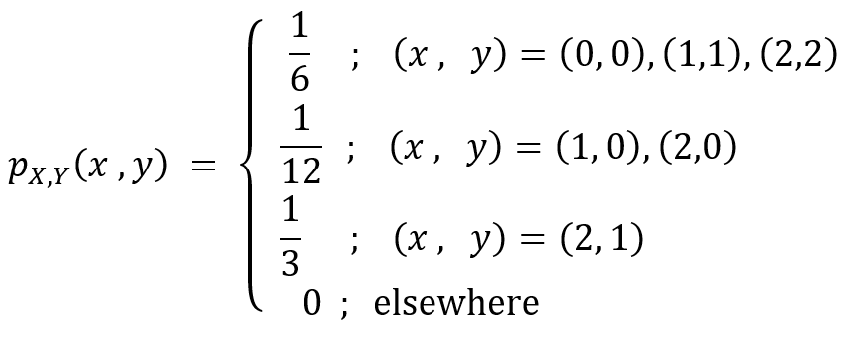

Compute the expected value of X/(X+Y+1). Your final answers must be a number.

Problem 3: Consider the joint probability distribution of X and Y given by
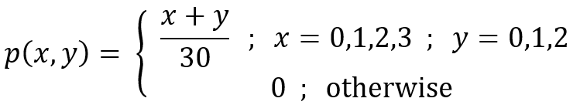

(a) Compute the E( XY + X² + 1 ).

(b) Compute the E(e^{sX}) where s is a constant.

(c) Use your results from Part b to compute E(X²).

Problem 4: Given the joint density function 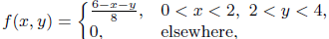

(a) Compute the E(e^{sX}) where s is a constant.

(b) Use your results from Part a to compute E(X).

Problem 5:
A current of X amperes flowing through a resistance of Y ohms varies according to the probability distribution
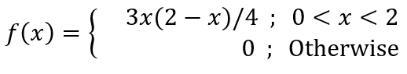
The resistance varies independently of the current according to the probability distribution
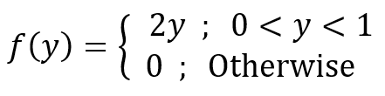
The power of this circuit is given by X²Y.
Compute the expected (or average) power. Your final answers must be a number.

Problem 6: Use ONLY MATLAB to answer this question.
Consider the joint pmf given by the following table:
 |  | Y
 |  | -1 | 0 | 1
X | -1 | 1/6 | 1/6 | 0
X | 0 | 0 | 0 | 1/3
X | 1 | 1/6 | 1/6 | 0

Use the following MATLAB code and edit as necessary to compute
(a) P( |X-Y| = 0) = (Provide your final answer here)
(b) E[ Y/(X² + 2) ] = (Provide your final answer here)
(c) Provide your complete MATLAB code (without output) here.

The following MATLAB code is for one of the examples we did in Lecture Notes 8 and 9. You may want to read and run each line of the following code to see what each does.

